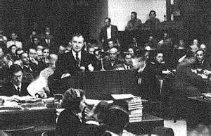
News Release

For more information please contact:
James C. Johnson
716.640.0261
jjohnson@roberthjackson.org
Robert H. Jackson at Nuremberg

10th annual International Humanitarian Law Dialogs:
The International Military Tribunal At Nuremberg
“A Lasting Legacy for the Future”

- 10th International Humanitarian Law Dialogs to be held in Nuremberg, Germany
- Commemorates the 70th Anniversary of the Judgment of the International Military Tribunal at Nuremberg
- Attended by 10 current and former International Chief Prosecutors
- The United States Attorney General, Loretta E. Lynch, to speak

The 10th annual International Humanitarian Law Dialogs are scheduled for Thursday, September 29th and Friday, September 30th in Nuremberg, Germany. Previously held at Chautauqua Institution in Western New York, this year the IHL Dialogs will move to Nuremberg to commemorate the 70th Anniversary of the Judgment in the International Military Tribunal. The IHL Dialogs will be held in Association with the City of Nuremberg, the Memoriam Nuremberg Trials, and the Documentation Center Nazi Party Rally Grounds.

The IHL Dialogs are an historic gathering of the current and former prosecutors of the international war crimes tribunals, renowned academics and international law experts. Annually, this unique event allows participants to engage in a meaningful dialogue about issues related to modern international criminal law.

To be opened by the Lord Mayor of Nuremberg, Dr. Ulrich Maly, and the Bavarian State Minister of the Interior, Construction and Transportation, Joachim Hermann, in the Historic Nuremberg Trials Courtroom 600, the IHL Dialogs will feature keynote addresses by Loretta E. Lynch, Attorney General of the United States; Fatou Bensouda, Chief Prosecutor of the International Criminal Court; and, Joseph F. Kamara, Attorney General for the Republic of Sierra Leone and former Deputy Prosecutor for the Special Court for Sierra Leone. Additional highlights of the program will include a Prosecutor Roundtable, with the current Chief Prosecutors of the International Criminal Tribunals and a panel discussion on German Perspectives on the Prosecution of Nazi Crimes.

Sponsoring organizations for the IHL Dialogs are the American Bar Association; the American Red Cross; the American Society of International Law; Case Western Reserve University School of Law and the Frederick K. Cox International Law Center; Impunity Watch; the International Bar Association; intlawgrrls; New York University Center for Global Affairs; the Planethood Foundation; the Public International Law and Policy Group; the Robert H. Jackson Center; Syracuse University College of Law; the Whitney R. Harris World Law Institute at Washington University School of Law; and, in association with the United States Holocaust Memorial Museum.
##

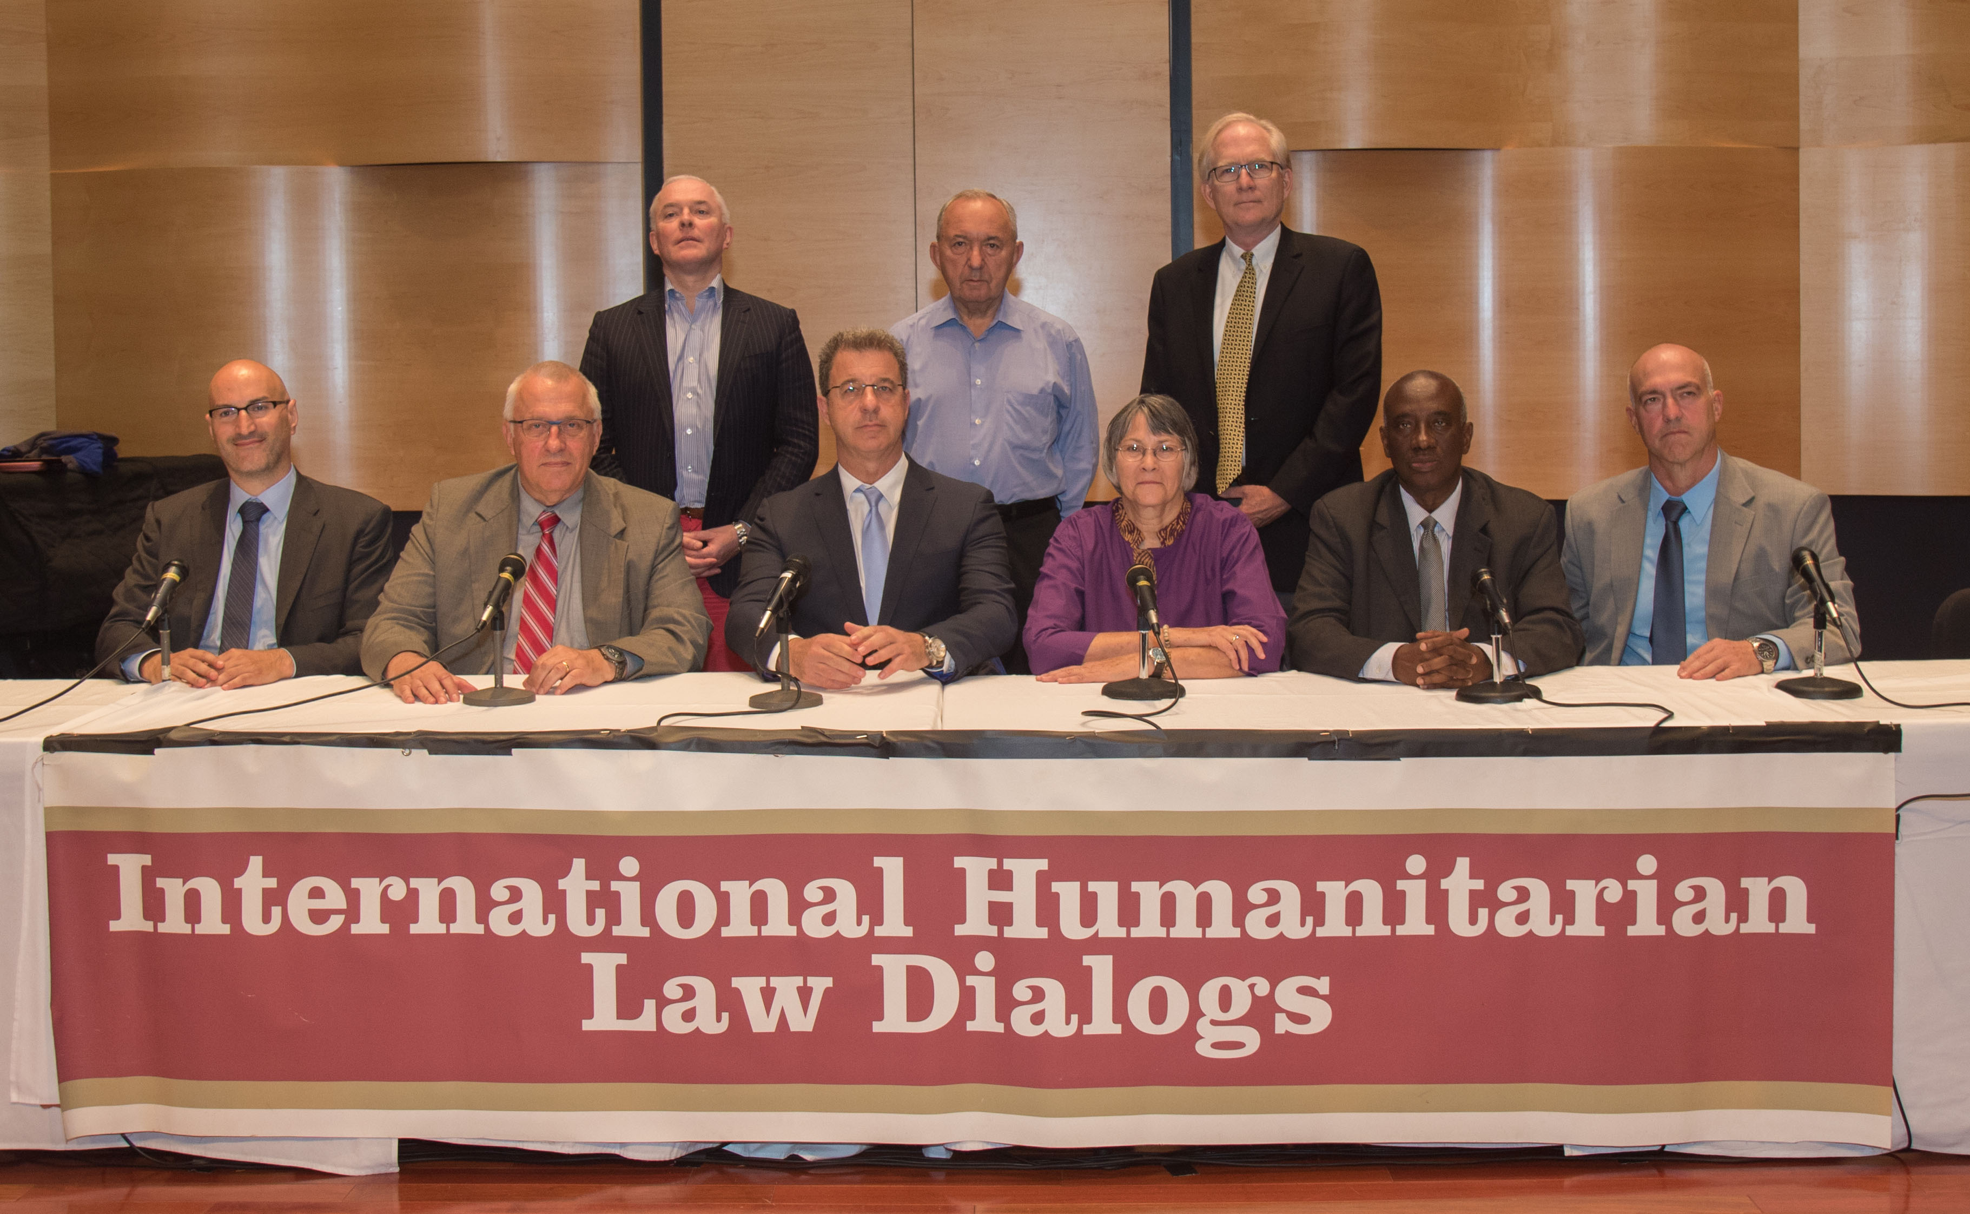International Prosecutors pictured at the 9th annual IHL Dialogs (2015)

